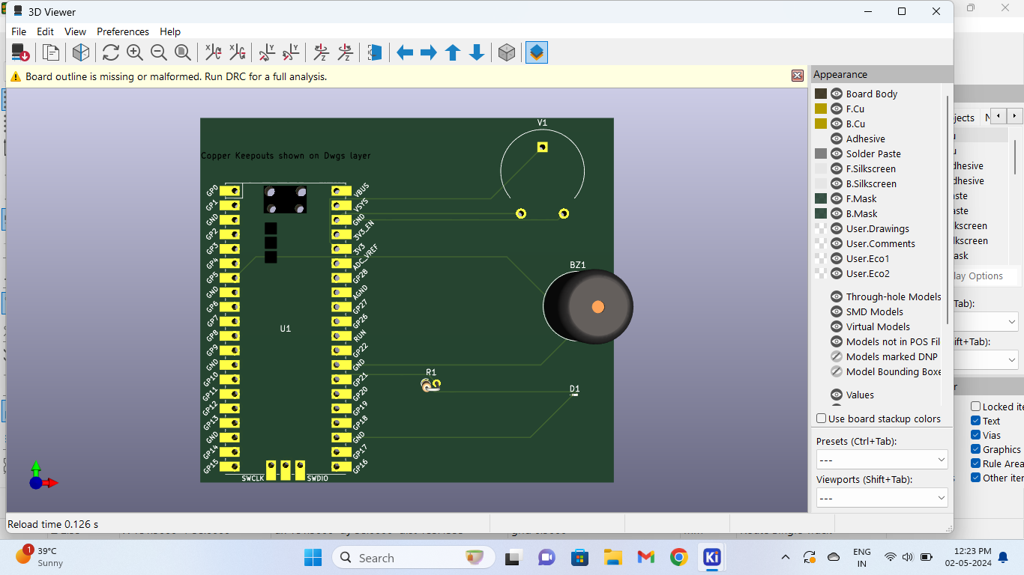

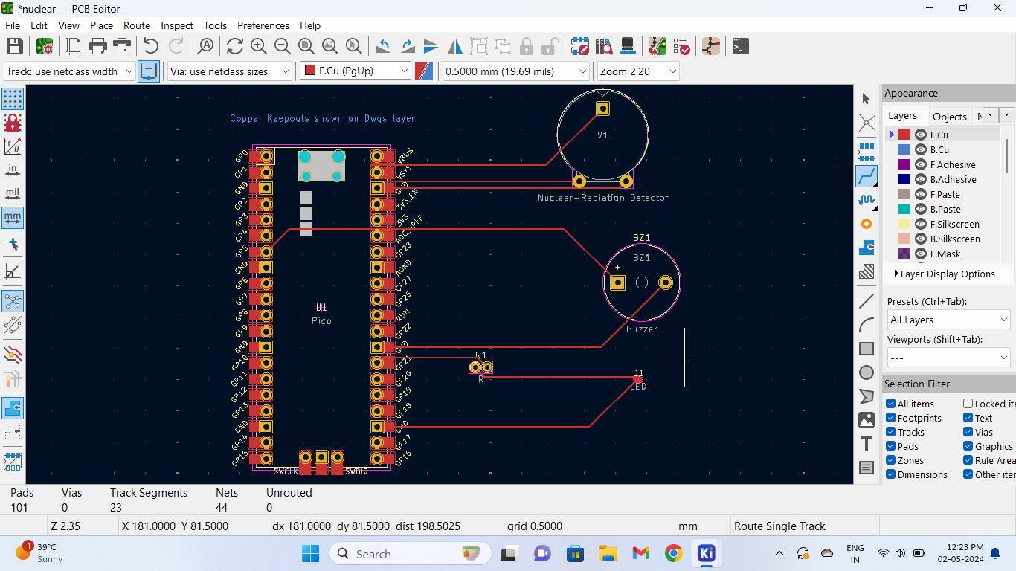

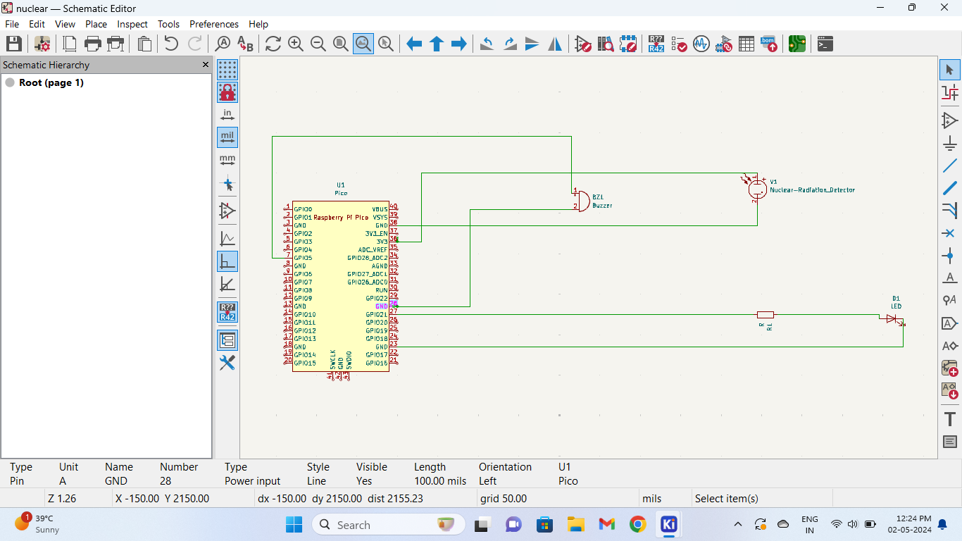

**NUCLEAR RADIATION DETECTOR**

**Project done by : Prathapaneni Tejaswini (21781A04F2)**

**N.Varalakshmi (21781A04C9)**